PE Activities  Click on this link and try the Pres PE Challenge!  TikTok/Instagram fitness challenges  - Hit Your Rollie Challenge  - Plank Partner Challenge  - Bottle Challenge  Try one of these challenges & share your results with the school.  Plank challenge- How long can you hold it for?  Wall sit- How long can you hold it for?  Burpee Challenge- How many can you do in 1 minute?  Tricep Dips- How many can you do in 1 minute?  Cultural Week  Create a brochure on '5 historical places to visit in North Kerry'  1st and 2nd Year Traditional Musicians : Ms. Ryan & Ms. Ní Chuain have a team set up and are going to post a tune in and host a competition  Ms. Ní Chuain & Ms. Daly will send a pre-recorded Sean-os dancing class to students Tuesday at 9.40am  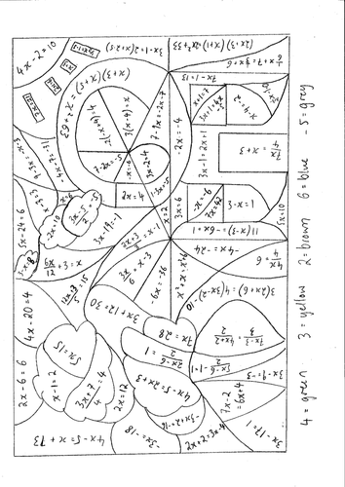  Irish  Dé hAoine  Tráth na gceist don scoil iomlán (School quz)  Dé Luain  Toraíocht taisce 1 & 2 (Treasure hunt 1st & 2nd years)  Dé Mairt  Comórtas seanfhocail 1-3 (Seanfhocail competition 1st – 3rd years)  Gaeilge I nmo cheantar 1-3 (Irish in my community 1st – 3rd years) |  | Activity Week  There will be no online classes from 2 to 4pm on Tuesday 16th March to vacilitate students to complete some of these fun activities!  Please email your pictures/videos, etc. to:  reception@preslistowel.ie  Prizes for each category will be given after Easter holidays! |  | Poetry  The English Department will run a poetry competition for the Junior Cycle students.  This will be in conjunction with National Poetry Day - April 29th.  Science Activities  Why not try one of the following & send your video/pictures to share with the school:  Create your own rocket  Find 5 examples of Science in everyday life  Assess your house for energy efficiency and create a list on how to make your home more sustainable  Create a meal to show chemical changes & chemical reactions  Home Economics  We would like to invite all students to prepare an entry for ATHE competition posted below.  Please send photos or video clips of your entry to Ms. Whelan or Ms. O’Connor on chat as we will choose a winner from our school.  You can forward your entry via Twitter if you’re entering the official ATHE competition please.

Music
Record & submit your musical performance
In class music quiz

Presentation Secondary School Listowel

Activity Week
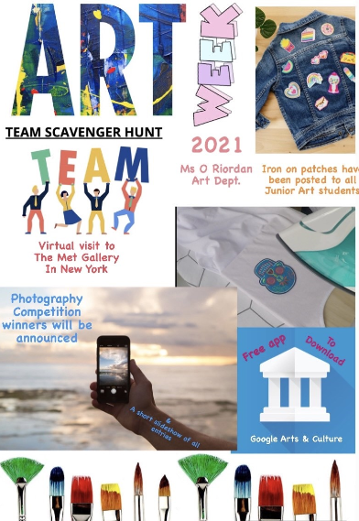

Maths challenge:
All participants who get the correct answers to this challenge will receive a prize after Easter!

