Presentation Secondary School Listowel
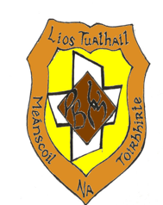
1st year Book List 2021/2022

Subject
Irish | Mol an Oige 1 Gill
English | Kingdom 1 - Educate
Maths | Active Maths 1 - Folens
French | Allons-y 1 - Educate
German | Viel SpaB 1 – CJ Fallon
History | Making History - Gill
Geography | Cyclone - Gill
Business Studies | Business Breakthrough - Mentor
Home Economics | JC Home Economics – Eilis Flood educate.ie
Science | Catalyst - Educate
Art | New book to be decided in Setpember
Technical graphics | New book to be decided in September
Music | Sounds Good 1 - Edco
Religion | Beliefs in Our World - Gill
SPHE | Provided by the school
CSPE | Make a difference - Folens

