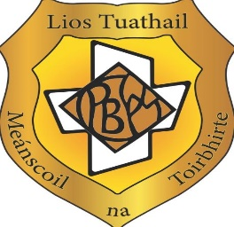 

**An overview of School Self-Evaluation (SSE)**

**What is school self-evaluation?**

School self-evaluation is a process that all schools are involved in. It is a ‘collaborative, reflective process of internal school review, focused on school improvement’. Self-Evaluation is also about maintaining high standards and improving learning experiences and educational outcomes for the students in Presentation Secondary School Listowel.

**When was school self-evaluation introduced?**

School self-evaluation was formally introduced into the Irish school system in 2012. In line with the guidelines, the process of self-evaluation commenced in Presentation Secondary School Listowel in 2012 / 2013. Each academic year since then an area of improvement has been identified and included in our School Improvement Plan.

**Why was school self-evaluation introduced?**

The school self-evaluation process builds on school development planning. It gives schools an opportunity to review their day-to-day practices and policies with a particular focus on teaching and learning.

**Who is involved in school self-evaluation?**

All members of the school community are involved in the process of school self-evaluation. In Presentation Secondary School Listowel the principal, deputy principal, teachers, students, parents and board of management all have a role to play.

**How does school self-evaluation work?**

As required by all schools we follow the guidelines *‘School self-evaluation guidelines 2016 - 2020’* and ‘*School self-evaluation: Next steps September 2022 - June 2026’*

School self-evaluation is an evidence-based process. There are six steps, which involve gathering information from a range of sources, analysing practices, making judgements about practices and about how well students are doing, compiling an action plan and implementing it. All actions taken are monitored and reviewed.

**What are the results of school self-evaluation?**

The key focus of school self-evaluation is to bring about improvements in students’ learning.