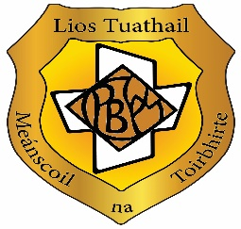

**OUR SELF-EVALUATION REPORT AND IMPROVEMENT PLAN 2024/25**

**This is what we did to find out what we were doing well, and what we could do better:**

Parent survey April/May 2024

Teacher survey on school self-evaluation strategies at an SSE Staff meeting on 22/08/24

Improvement targets identified for the academic year 24/25

These targets were presented to the Board of Management by the SSE Coordinator on 01.10.24 and approved by the Board.

Teaching and Learning Survey completed and analysed Term 2

Student survey and focus group on student learner experience completed Term 2

**In the last year, we have looked at teaching and learning in our school to find out what we are doing well. This is what we discovered:**

* 100% of staff now using Microsoft Teams (since it was introduced in Sept. 2018)
* Staff engagement with professional collaboration through team teaching across many subjects.
* SSE and Teaching and Learning teams promoting collaborative practice in line with Junior Cycle framework.
* Students’ achievement is acknowledged and celebrated by the school community, on the school website, in local media outlets, on the school’s various social media platforms, at assemblies and in displays in key areas of the school.
* School stakeholders through its Board of Management and parents (as evidenced by an active Parent’s Association) are highly committed to school support and development.

There is an increased use of technology by teachers and students

Students feel safe at school

Students are encouraged to work hard and try their best and know how to access help at

school if needed

We offer a variety of extra-curricular activities

**This is what we are now going to work on:**

Consolidate and expand the good practice established through previous school improvement plans on active teaching methodologies such as group work and pair work

Increase the use and quality of digital learning tools in the classroom

Increase teacher collaboration

Increase opportunities for student collaboration and student voice through cooperative learning

Promote well being

**This is what you can do to help:**

Encourage your daughter to attend school every day she is well

Support and monitor your daughter’s learning

Ensure your daughter has good habits at home to enable learning

Encourage participation in group work and collaboration with peers

Encourage participation in school life and extracurricular activities to promote connection and wellbeing

Communicate any issue or concerns regarding your daughter to the school through the appropriate channels

Get involved with our Parents Association