Presentation Secondary School Listowel

School Improvement Plan 2024/25

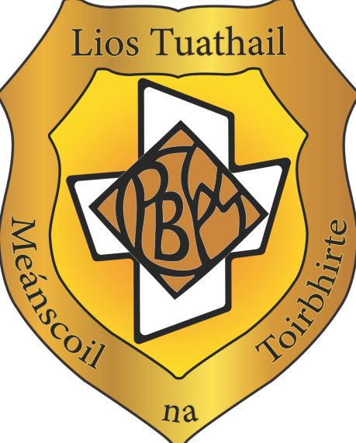

# School Improvement Plan Presentation Secondary School Listowel 2024/25

|  |  |  |
| --- | --- | --- |
| STRENGTHS |  | * Students’ attainment in summative assessments, including certificate examinations, is in line with or above expectations. * Students demonstrate very high levels of interest and participation in learning. * Teachers have high expectations of students’ learning and behaviour and communicate these expectations effectively to students. * Teachers use formal meetings and planning time to reflect together on their work a plan collaboratively. * The school community fosters a strong commitment to inclusion and the holistic development of each student. * There is a whole school commitment to listening to the viewpoints of students and there is a positive, systematic approach to fostering opportunities for ‘student voice’ to be shared with the school community. |
|  |  | * There are very good pastoral and SEN structures in place (teacher practice) including excellent Guidance and Student Support services. |
| MAIN AREAS  REQUIRING  IMPROVEMENT | • | Build whole- staff capacity in pedagogy, by facilitating teachers who are willing to share their expertise with other teachers in the school with the establishment of a peer support system of collaborative practice. |
|  | • | Develop a whole- school collaborative approach to the implementation of the ‘Helping Hands Anti Bullying Programme’ which supports and complements the SSE process in relation to embedding a positive school culture that prevents bullying behaviour and ensures the psychological safety of every student. |
|  | • | Align the implementation of the increased use of co-operative learning strategies with the standards of effective and highly effective practice as outlined in the ‘Looking at Our Schools 2022’ document. |
|  | • | To increase the awareness of the role of team work and group work in the ‘Key Skills of Junior Cycle” in particular in the area of creativity in learning. |
| IMPROVEMENT TARGETS |  | * Continue to develop a common approach to team work throughout the school by increasing the use of co-operative learning strategies. * Continue to examine the power dynamic in class groups and ensure the psychological safety of students through implementing co-operative learning strategies and the Helping Hands Anti Bullying Programme. * Implement a peer observation system to support the use of co-operative learning strategies in classes. * Achieve high level student engagement in learning through increased teacher use of co-operative learning strategies whereby students become engaged thinkers, active learners and knowledge constructors. |
|  |  | * To improve teacher competence and confidence in the use of co-operative learning strategies. |
| REQUIRED ACTIONS |  | * Share and raise awareness of the “The Helping Hands Anti-bullying programme” and to encourage and support teachers in its implementation. * To establish a peer- support network of collaborative practice where teachers share knowledge and expertise and support colleagues in the implementation of co-operative learning strategies. |
|  |  | * Encourage all staff to begin or continue to use co-operative learning strategies in the classroom within a certain timeframe. This may be carried out with the support of a peer observation strategy and/or alternatively following demonstrations on the use of co-operative learning strategies by colleagues. * Share information on the role of team work and group work in the “Key Skills for Junior Cycle” and to foster a commitment to their implementation, |
|  |  | * Develop banks of co-operative learning strategies for teacher use within subject departments and to incorporate them into teaching and learning plans. Subject departments to review the outcomes of the implementation of co-operative learning strategies at subject department meetings. |
|  |  | * To share knowledge of co-operative learning strategies across the whole- school. * Year Heads in collaboration with subject teachers will collaborate to implement the “Helping Hands” teams in each class to ensure to psychological safety of each student and build a positive classroom culture where students feel comfortable to share their views and opinions. |
|  |  |  |
|  |  |  |
| PERSONS  RESPONSIBLE | • | School management  Subject departments |
|  | • | Individual subject teachers |
| TIMEFRAME FOR ACTION | • | September 2024-May 2025 |
| SUCCESS  CRITERIA/ MEASUREABLE OUTCOMES |  | * Increased confidence, competence and frequency of use of co-operative learning strategies in learning and teaching practices with a particular emphasis on developing creativity in them. * Pupil surveys and responses on classroom activities – assess satisfaction with co-operative learning strategies. * Teacher surveys and responses on embedding co-operative learning strategies and ‘The Helping Hands Anti-bullying programme’ assess confidence and satisfaction with the use and effectiveness of co-operative learning strategies. * Student focus groups. |
|  |  | * Subject departments resources e.g., bank of recommended co-operative learning strategies. * Student feedback through the newly established Bí Cineálta team |
|  |  |  |
|  |  | * Staff evaluation (feedback from staff meetings, questionnaires, day-to-day conversations etc) |
| REVIEW DATES | • | May 2025 |